User Manual – New iTracks

logo

|  |  |  |  |  |
| --- | --- | --- | --- | --- |
| **Version No.** | **Release Date** | **Prepared by** | **Reviewed by** | **Approved by** |
| 1.0 |  | Priya Dharshni |  |  |

Contents

User Manual – New iTracks 1

1 Overview 3

1.1 Accessing the Application - iTracks 3

1.2 Login page 3

2 Admin user journey 4

2.1 Customer Setup 5

2.1.1 Customer Mapping 5

2.1.2 Work order configuration 6

2.1.3 Workflow Configuration 7

2.2 Workflow list Master 7

2.3 Job Norms Mapping 9

3 Project Manager- User journey 12

3.1 Work Orders list 12

3.2 Create new Work Order 14

3.3 Stage Mapping 17

3.3.1 Adding sub jobs 18

3.3.2 Assign stages 19

4 Team Member user journey 22

4.1 Accessing the Task- Manual Logistics Entry 22

4.2 Task screen actions 22

5 Screens accessible by all users 23

5.1 Query 24

6 Reports 25

6.1 On Time Delivery Report (OTD) 26

# Overview

## Accessing the Application - iTracks

The iWMS application can be best accessed by either of the below mentioned options,

1. Via CHROME/EDGE browser in WINDOWS and SAFARI/CHROME in MAC by launching the link  <https://iwms.integra.co.in/>
2. By launching the New WMS Thin Client application from the iTools menu. Navigate to iTools -> Software -> General -> New WMS

## Login page

1. Enter the employee ID (ISNO) in the username field and password in the password field. Password is user’s System password
2. Click on the LOGIN button after entering the right credentials to access the iWMS application.
3. If the user is mapped to different DUs he will be able to choose the DU to work on.
4. Once the user log into the application, based on the role and skill mapped the entire menu will differ

**Prerequisites**

1. Make sure the User’s system is connected to the internet.
2. In case the user is working remotely, make sure the system is connected to VPN
3. User should be mapped to a DU and be mapped to the respective Role and Skill
4. The New WMS Thin Client application must be installed for the user machine.

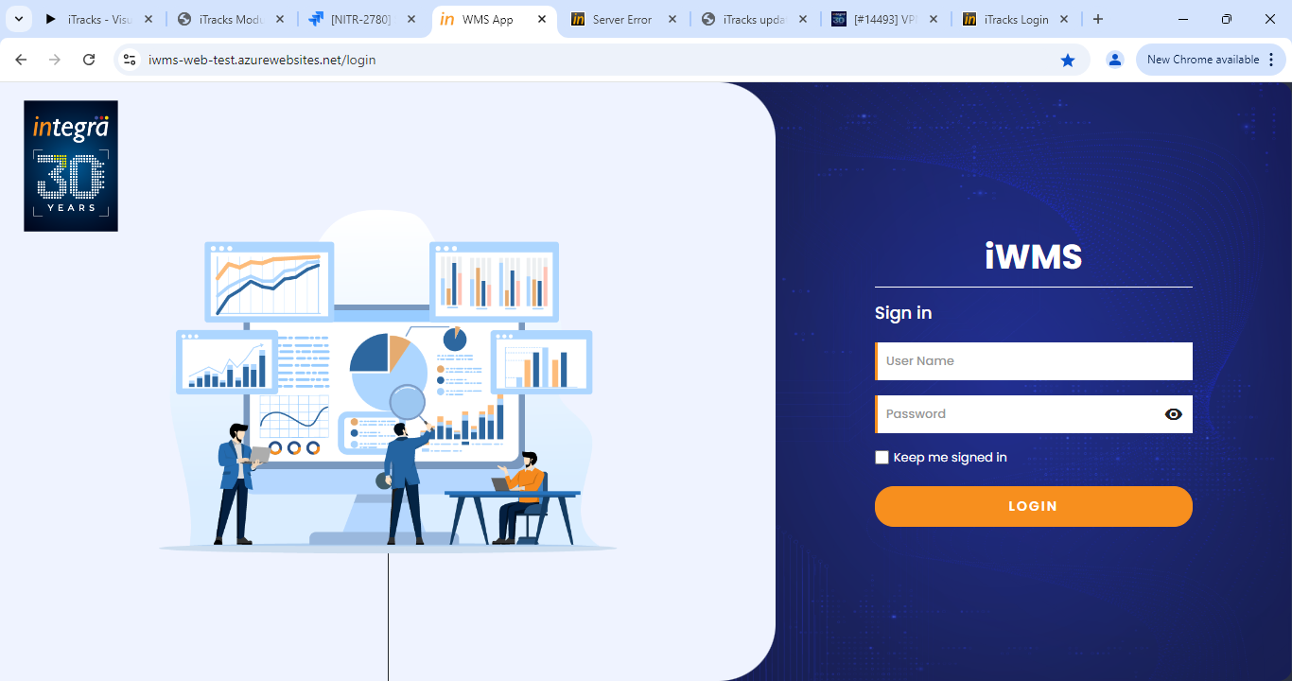

# Admin user journey

For the Admin, the application will direct the user to the landing page.

Master menu will be available in the side menu

## Customer Setup

The Customer setup menu will be available in the Master menu. The customer setup landing page will list all the previously configured customer setups.

Click on the Add new button to add new customer configuration.

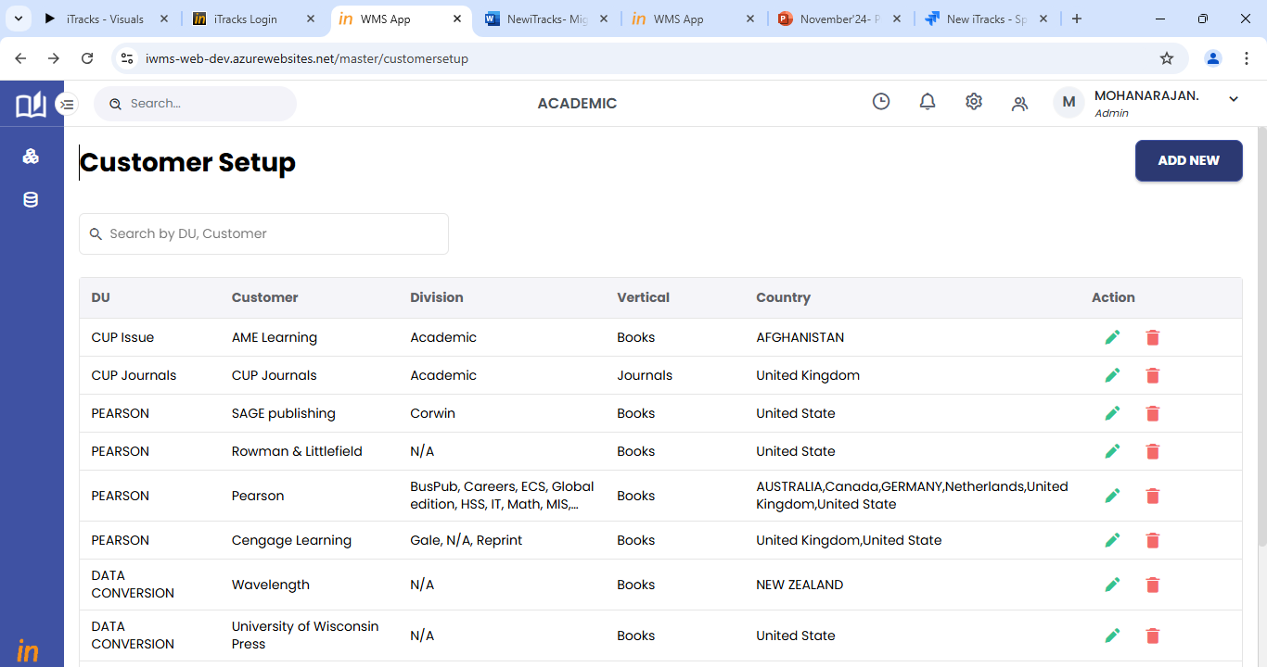

### Customer Mapping

1. Step 1 will be customer mapping.
2. Map the customer to DU, Division, Vertical and country. Division and country can be multiselected.
3. Select the type of customer for the mapped combination.
4. Select the required sections to be displayed for the mapped customer combination.
5. Click on save and next to move to the next step.

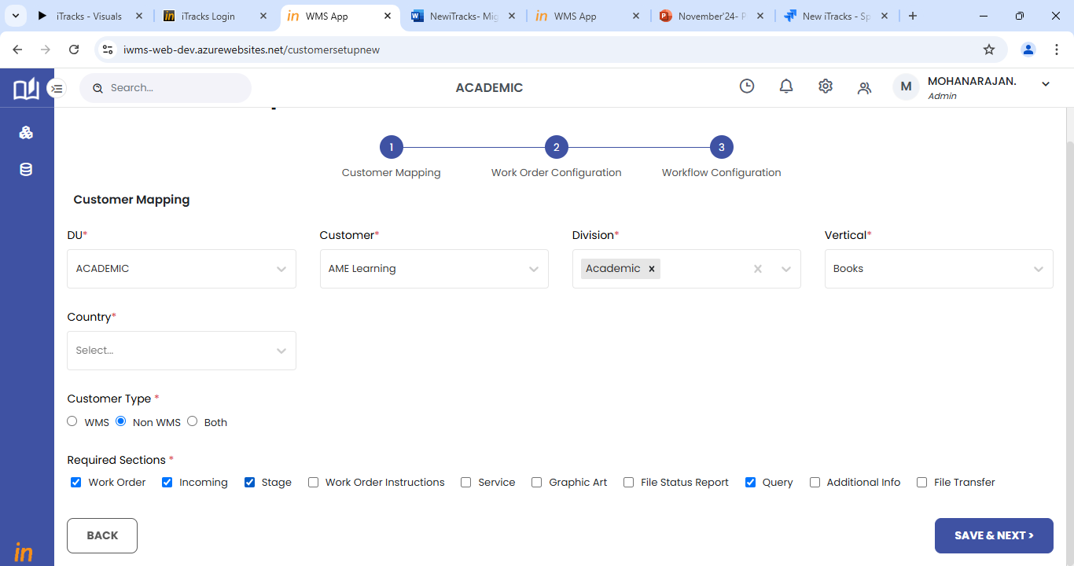

### Work order configuration

1. Step 2 will be work order configuration
2. This page will allow users to select the sections and fields that will be required to create a new work order.
3. A new work order can be created based on the configuration setup done in this step.
4. Use the settings icon on right to select the sections applicable for the customer mapping combination.
5. For each section, the user has to select the fields that are required.
6. The list of all the fields available will be displayed in the left pane of the page.
7. Users can select the required fields from the list.
8. Users will be able to choose the mandatory fields as well.
9. Click on save and next to move to the next section or page.

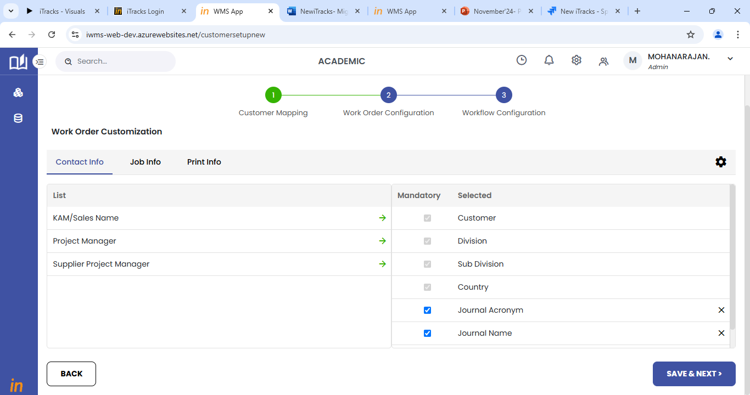

### Workflow Configuration

1. Step 3 will be workflow configuration.
2. Users can select the required workflow from the list of workflows available.
3. If the user wants to add a new workflow, it must be done in workflow list master as explained in section 2.2.

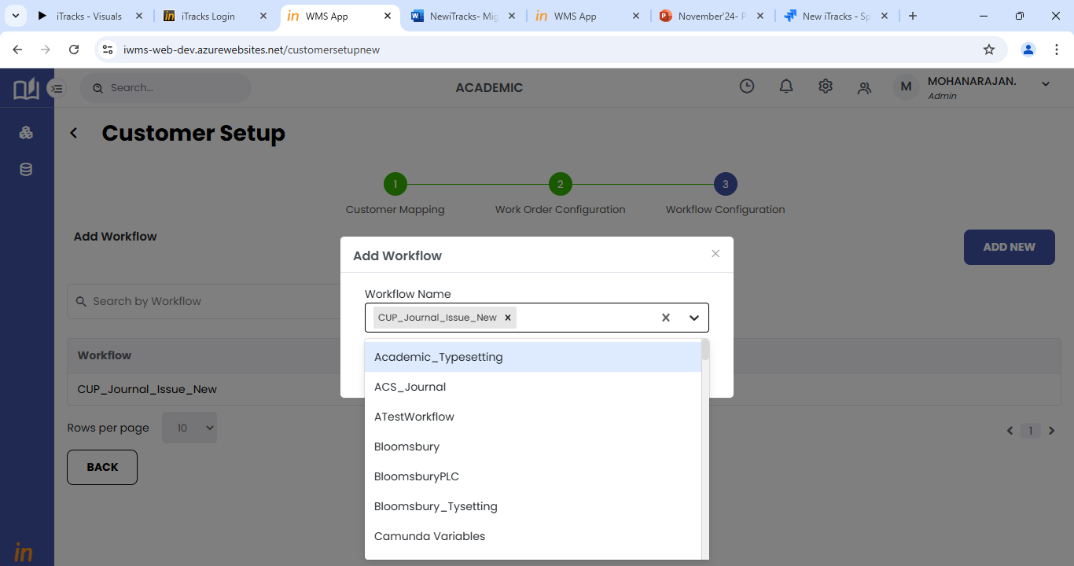

## Workflow stage and activity mapping

The workflow list master is a master for all the workflows in the system.

Workflow master can be accessed from the Main Master menu available in the side menu of the application.

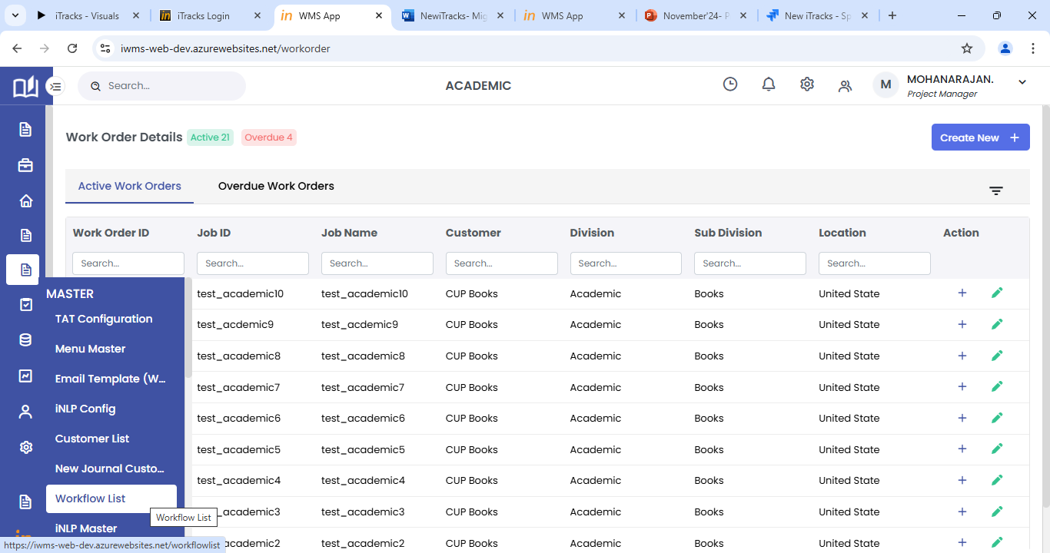

1. The workflow list will display all the workflows available in the system.
2. Click on the settings icon against each row to configure the workflow.

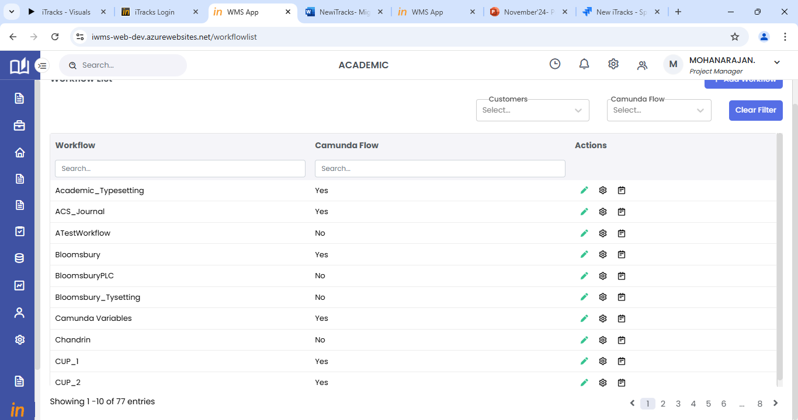

1. For workflow configuration, the user must complete the Stage order and activity order sections.
2. The stage order will list all the available stages in the left pane of the page.
3. The user can select and move the required stages to the right side.
4. After adding the stages, click on save to save the stages list and move on to the next step activity order.

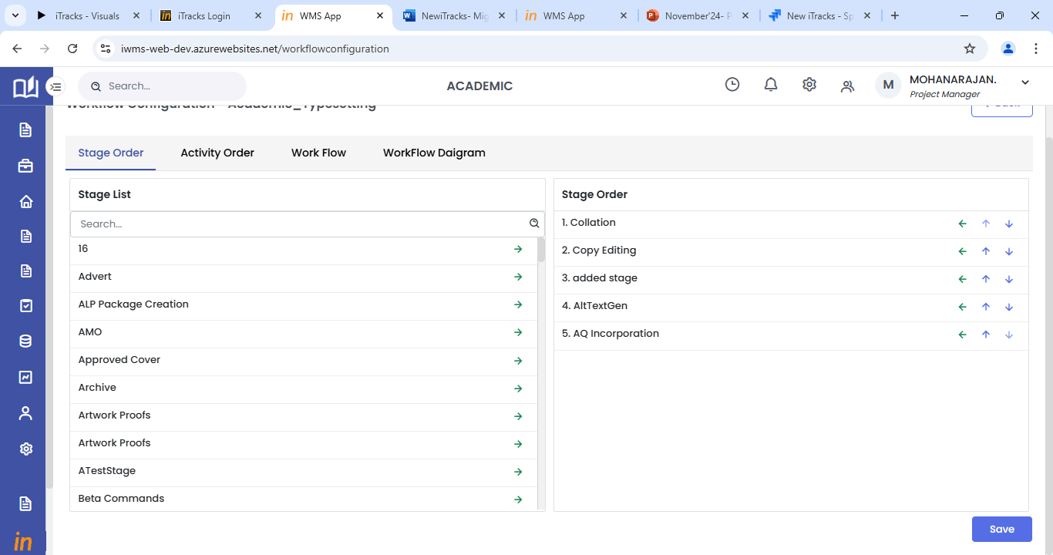

1. The activity order will list all the available activities in the left pane of the page.
2. The user can select and move the required activities to the right side.
3. Select the stage from the drop down provided and then select activities for each stage.
4. After adding the activities, click on save to save the stages and activities configuration.
5. Once added here, the workflow will be able to be selected in the customer setup screen.

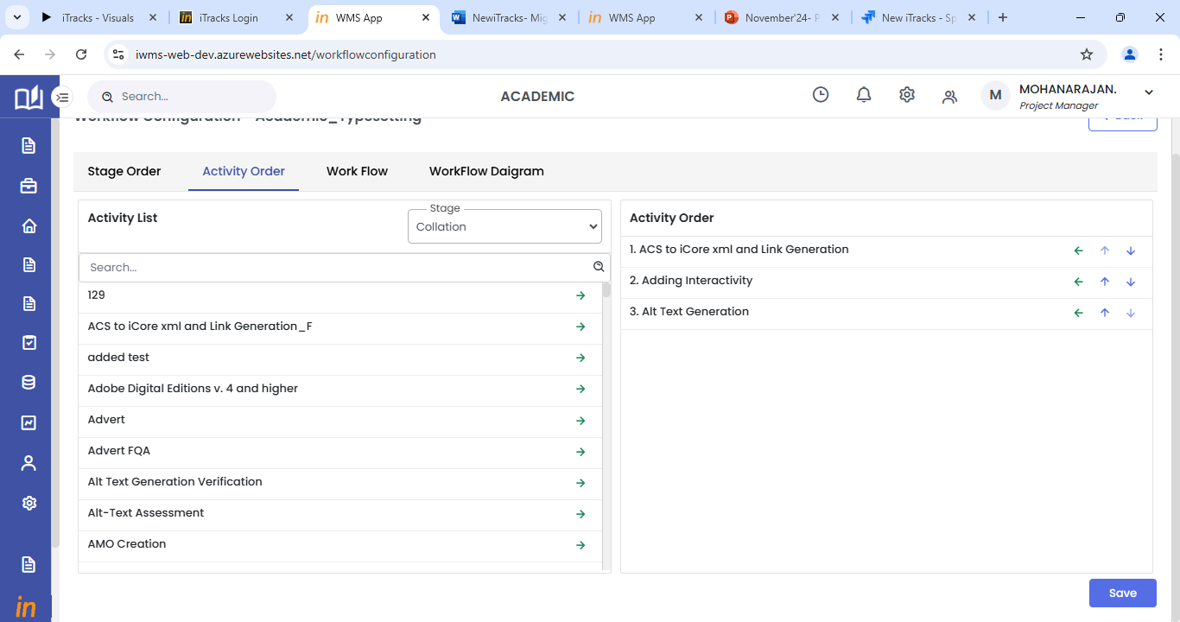

## Job Norms Mapping

1. Norms can be mapped by the Estimations lead user role.
2. Login to the system with the right credentials provided.
3. From the side menu, select Production menu.
4. In the Production menu, click on Job Norms to access the job norms mapping page.
5. In the Job norms mapping page, the first step will be to choose the DU for which norms have to be mapped.
6. Then select the customer using the + icon provided. Multiple customers can be added.

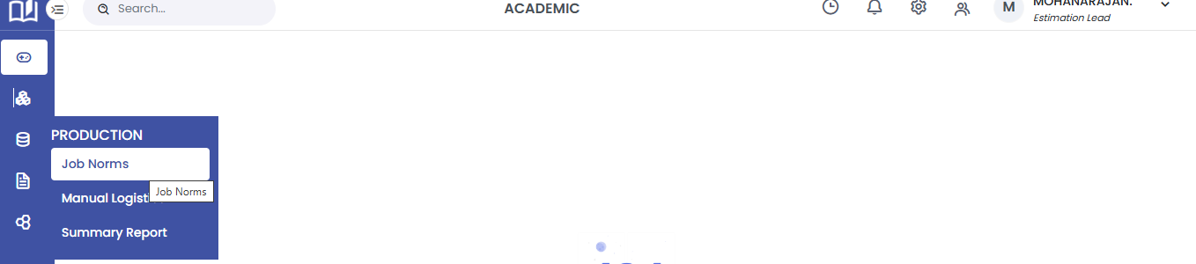

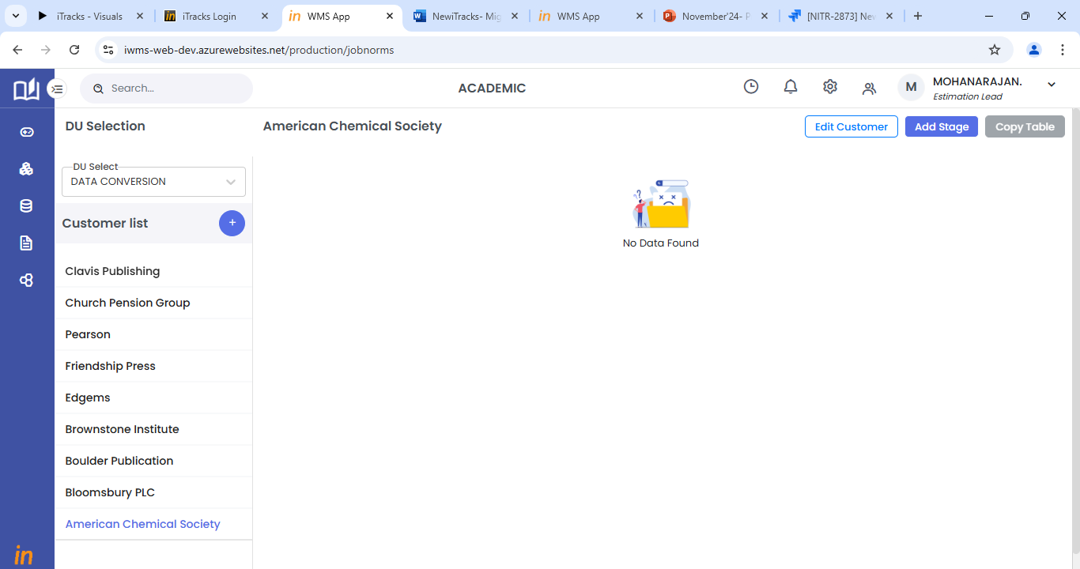

1. Click on the Add Stage button to add the workflow and stage for which norms have to be mapped.
2. Select all the required fields and click on save to add the stage.

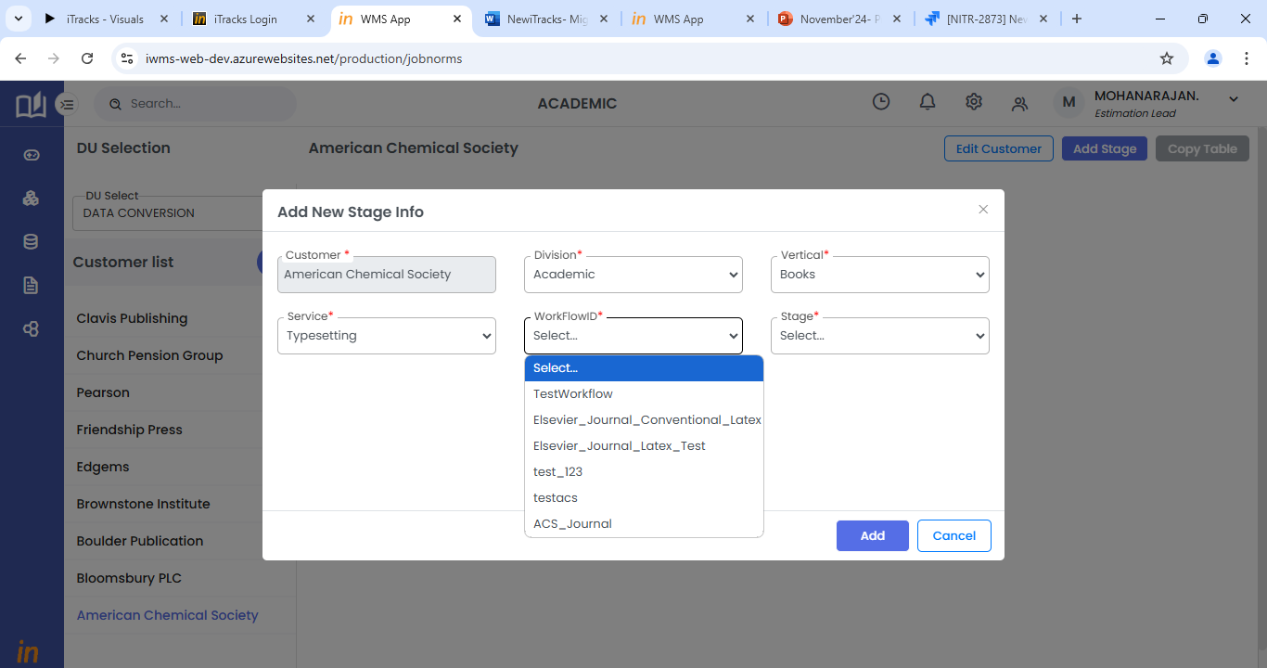

1. Once stage is added, click on the view icon to add activities and norms details.
2. In the view page, click on + icon to add activities for that stage.

Norms can be added for each activity by selecting the required activity once it is added.

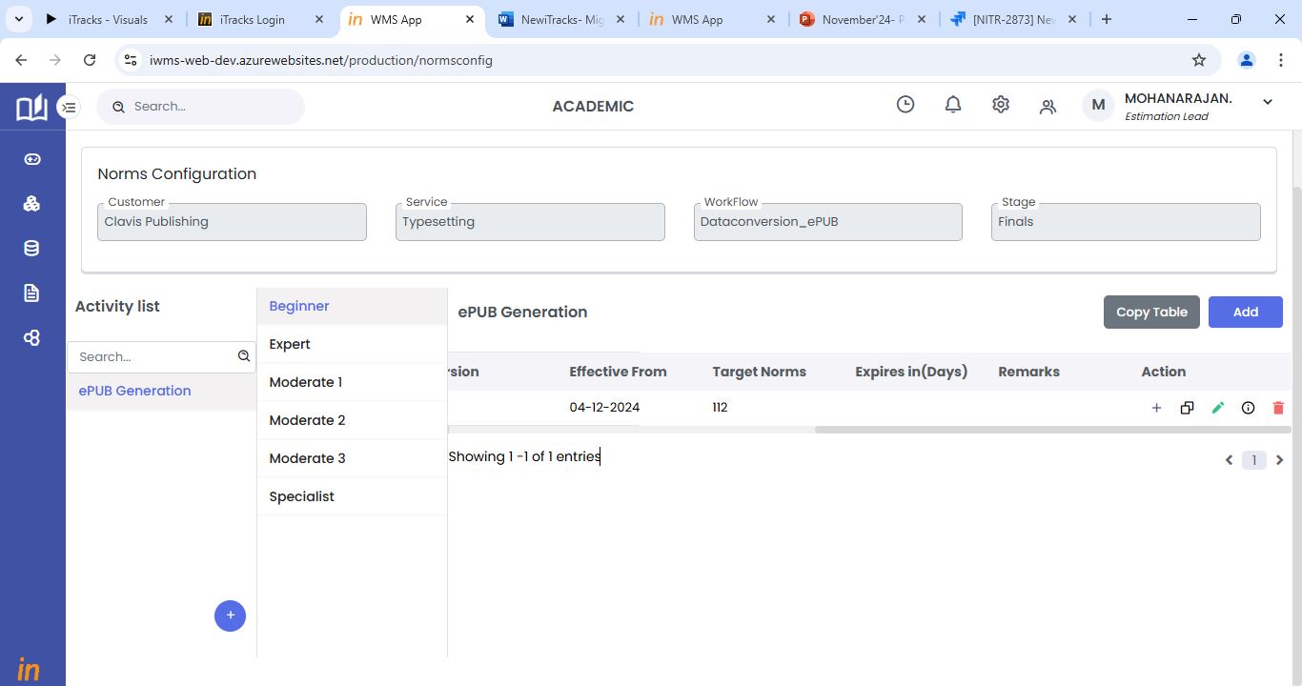

1. Users will be able to select the skill competency for each activity. Norms must be added for all the required skill competencies.
2. Click on pencil icon to edit the norms details
3. Click on copy icon to copy the norms details to another activity or competency.

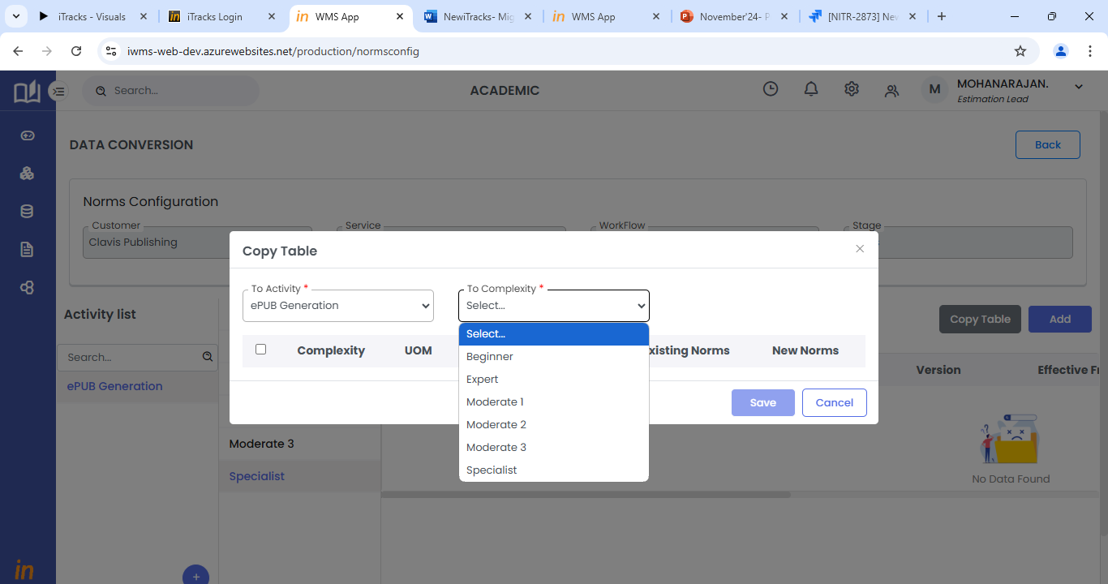

1. Add button will allow the user to add another iteration of the same activity.
2. The copy table button will allow the user to copy the norms details to another activity.

# Project Manager- User journey

For the PM, the application will direct the user to the landing page.

Side menu of the application will have the following Menus.

* Work Orders
* Task
* Reports
* Master

## Work Orders list

1. Click on the **Work Orders Menu** to view the existing workorders (Active and Overdue) list or to create a New Work Order
2. Use the scroll bar to move across the list

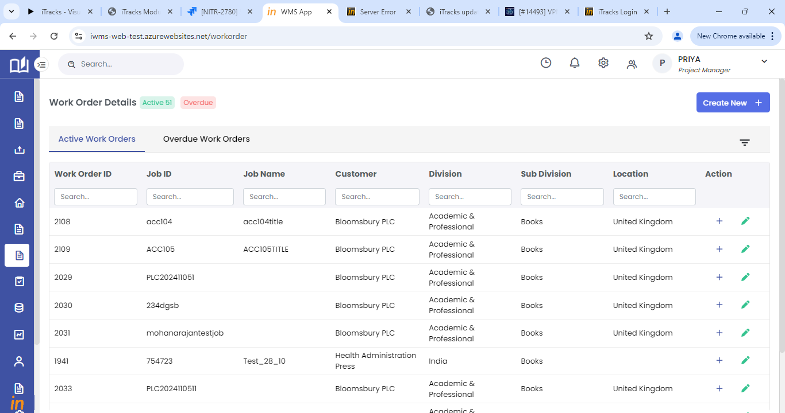

1. To search for a particular work order, use the search filter option provided for each column.

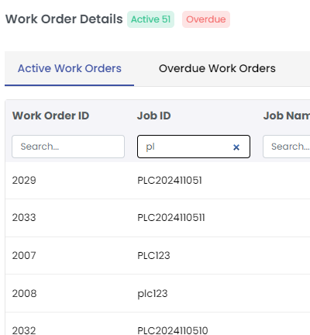

1. Under Action column, Click on the ‘**+**’ button to expand the row which will display the key information tabs (clickable hyperlinks) associated with the workorder.
2. The following menus will be displayed as hyperlinks, Job Info, Stage, Query.
3. Click on the required Menu item to go to respective work order tab.
4. Under Action column, click on the **Edit** icon to edit respective work order details.

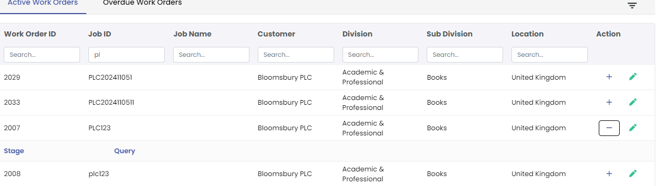

## Create new Work Order

A work order can be created manually by clicking the create new button from the Work order home page.

1. Use the **Create New +** button to create a new Work Order.
2. Choose for which type of customer the work order has to be created (WMS or Non WMS). The screens change as per this selection.

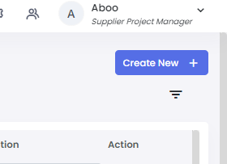

1. For Non WMS customers, Select the DU, Customer, Division, Vertical, and country for which work order has to be created.
2. DU will be auto populated based on the logged in user’s DU.
3. Select the relevant Customer, Division, Vertical, and country from the dropdown provided.

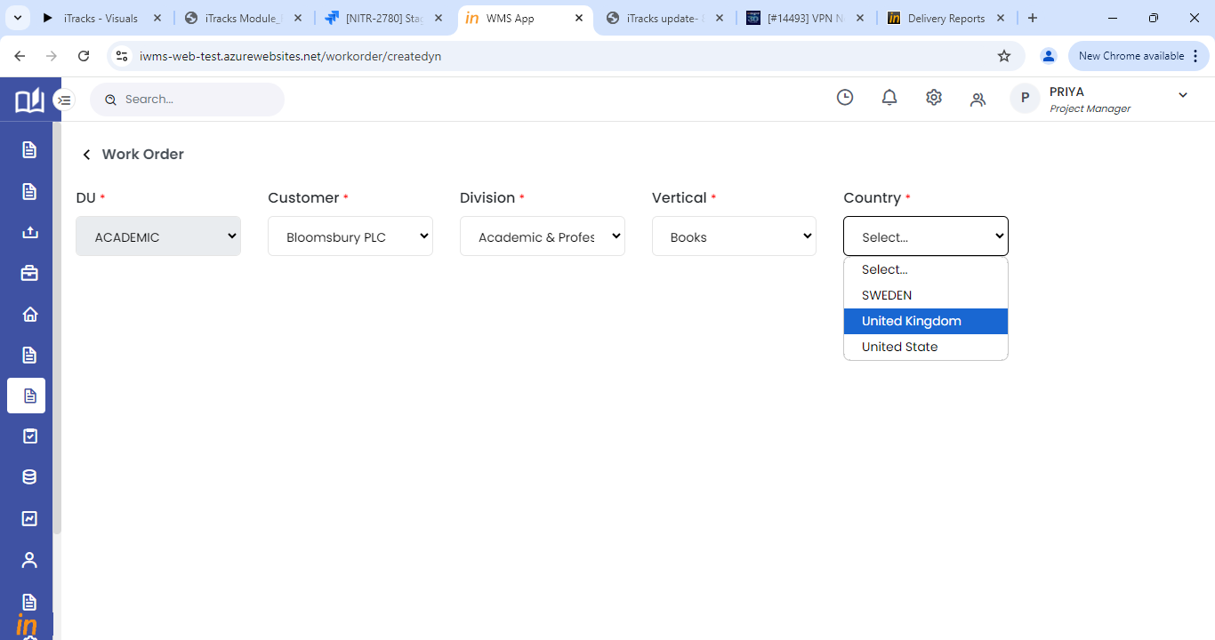

1. Once selected, the page will display the application tabs as per the customer setup made.
2. To create a work order, user has to fill all the mandatory fields in the sections configured as per the customer setup.
3. In all configured sections, select relevant data from the drop down provided for various fields.
4. Some fields will get auto-populated based on customer, division, sub-division, country configuration. If there are more than one contact mapped, it will not get auto populated, please select the contact from the drop down provided.
5. If you wish to clear the entered data, click on the **Reset** button.
6. To move to the next section after entering the contact details, click on the **Next** button.
7. The last section will have the **save** button.

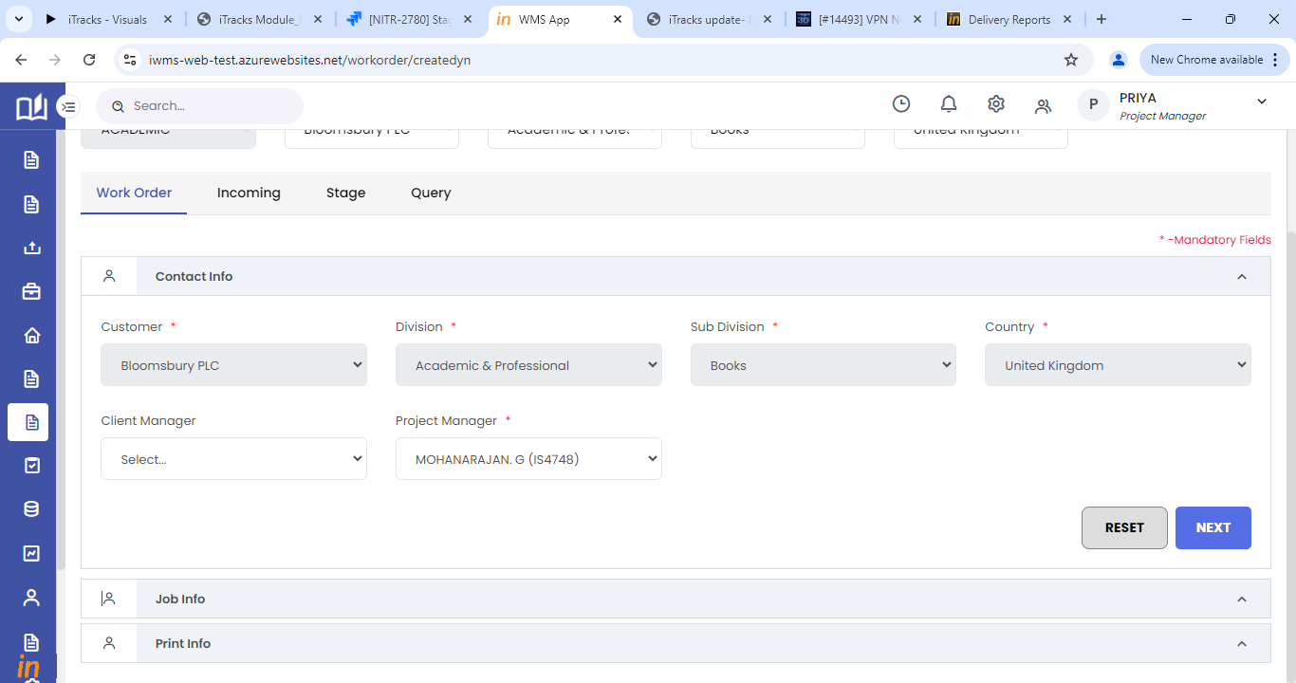

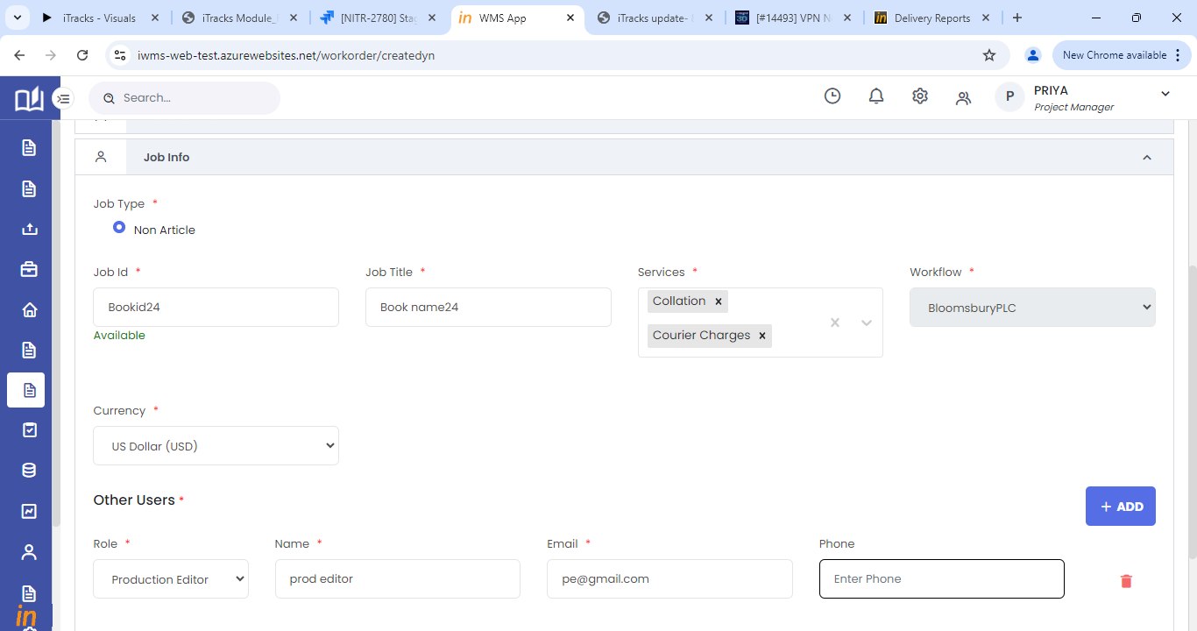

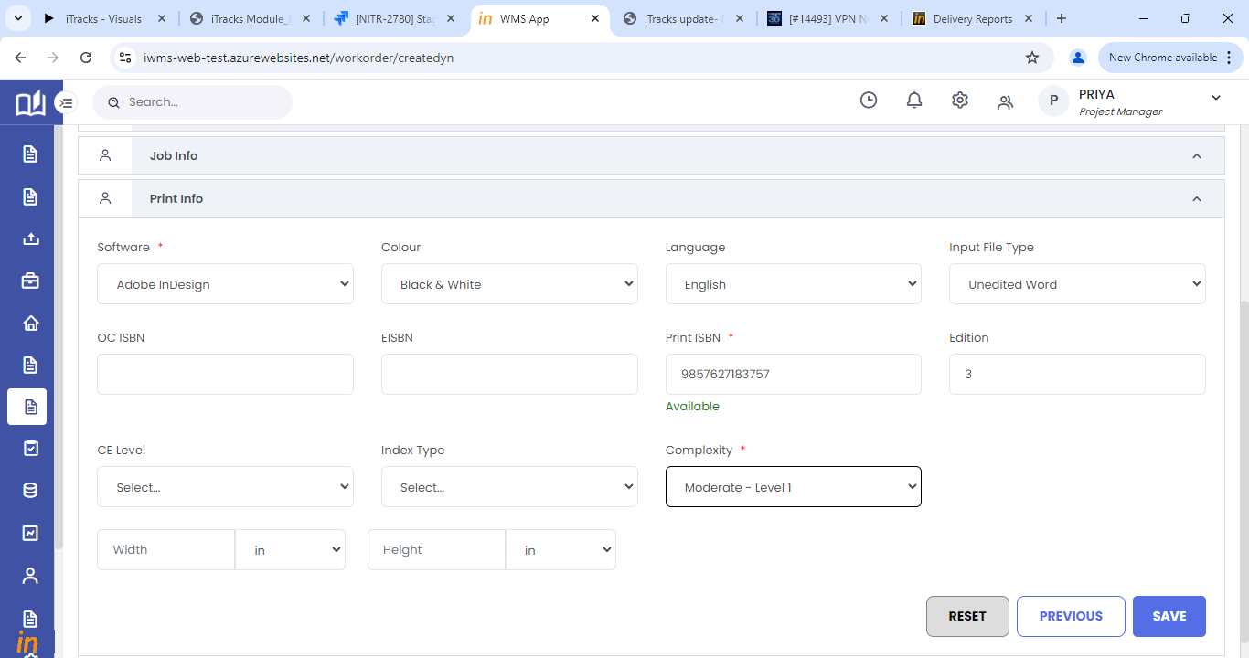

1. On click of save in the last section, the work order will be created.

## Stage Mapping

1. Incoming inspection has to be completed before mapping the stages.
2. Incoming inspection will be done by the Incoming team members. The process is as below.
3. Login with the right credentials provided.
4. Click on the Work orders menu from the side menu.
5. In the Active work orders tab, click on the + icon against respective work order to expand the row
6. Click on the Incoming menu to go to the respective work orders Incoming tab.

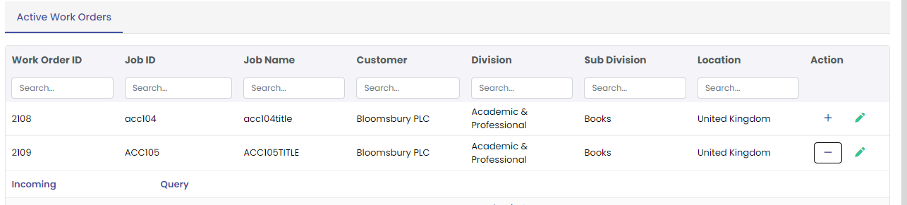

### Adding sub jobs

1. Click on the **+Add Sub job** button to open the add sub job form
2. Enter all the required information for the sub job (type, file name, ms pages, est pages, images, etc)
3. After entering the details, click on the save icon to save the sub job details.

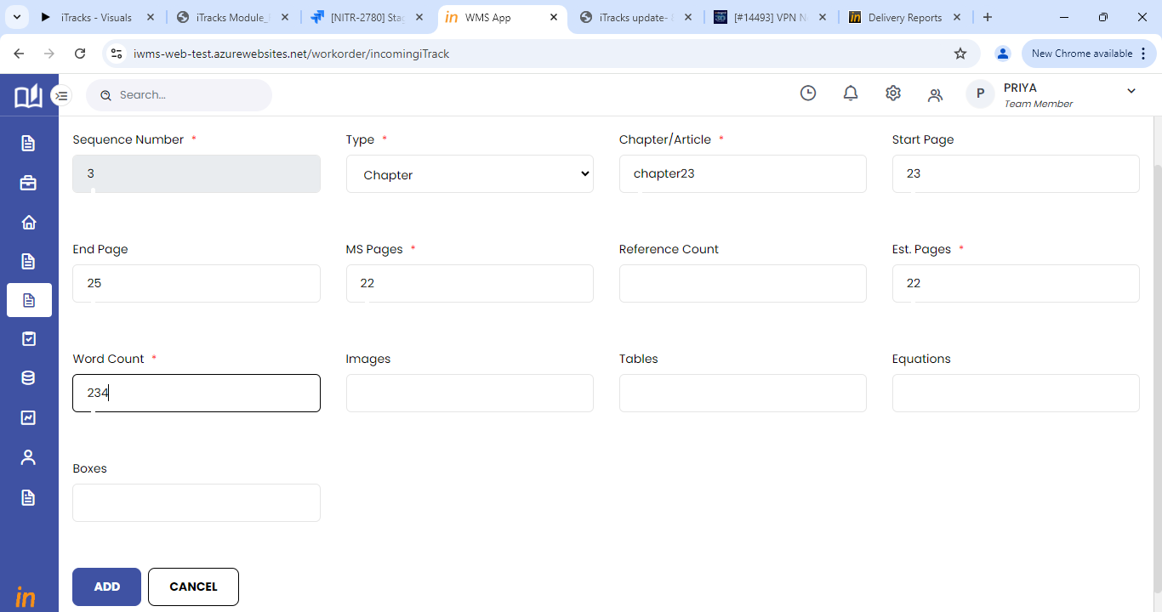

1. Once sub jobs are added, it will be displayed in the incoming home page.
2. Click on edit icon against each sub job to edit the sub job details.
3. Edit is allowed only until task claim.

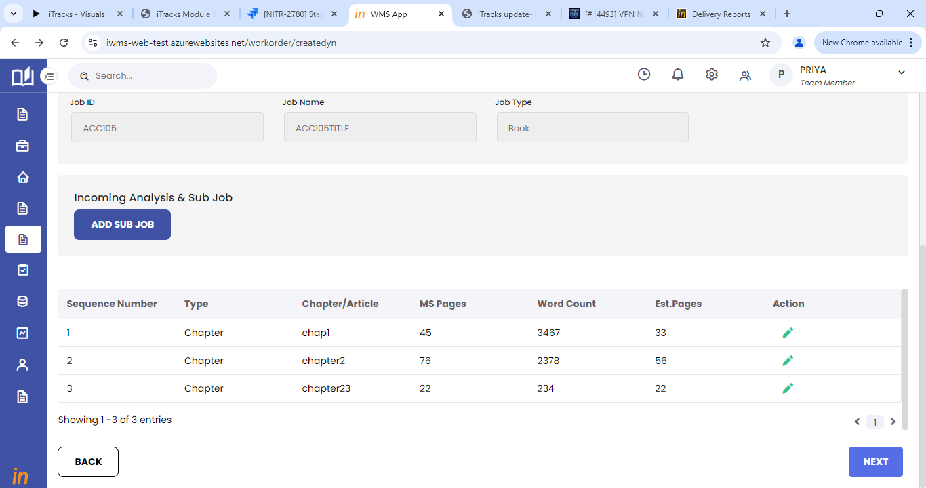

### Assign stages

PME (Project Management Executive) team will be able to assign stages and set due dates for the added sub jobs.

**Case 1**: PME team assigns stage for first time

1. Click on **Assign stage** button to create stages for the sub jobs.

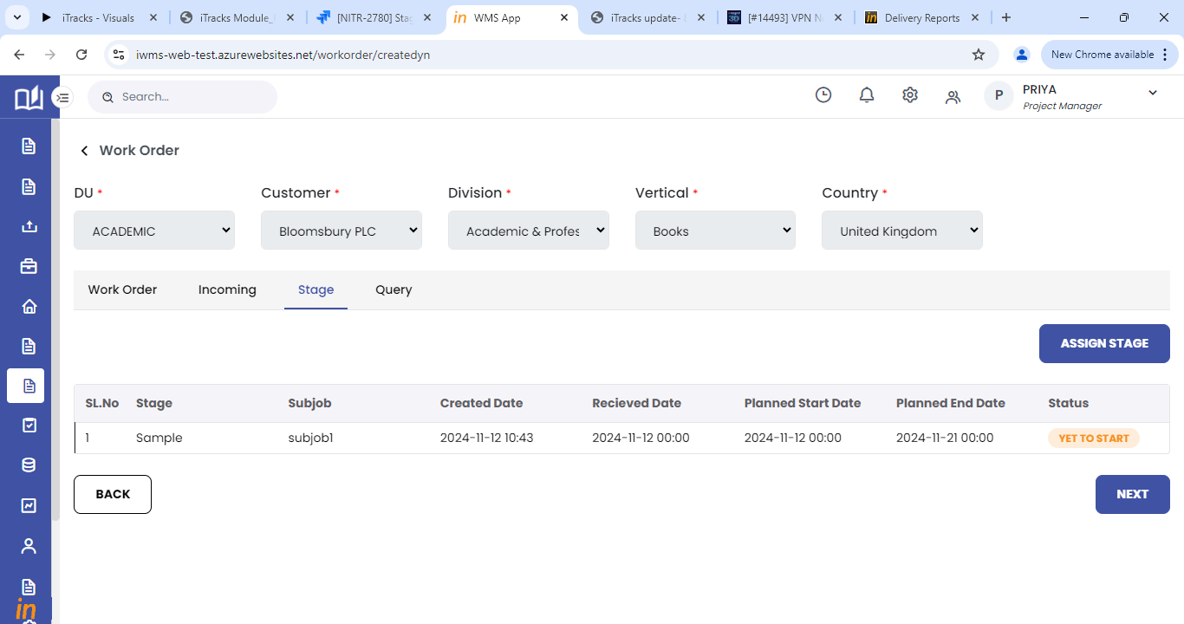

1. Assign stage will allow user to view and add sub jobs to a stage
2. Select the stage to be created from the stage dropdown.
3. Choose the iteration of the stage.
4. Select the sub jobs which you want to add to this selected stage.
5. Enter the received date, planned start date and planned end date for the sub job.
6. The received date and planned start date can be added only once for a stage.
7. Once stage details are added, Stages will be assigned to stages and due date will be set.

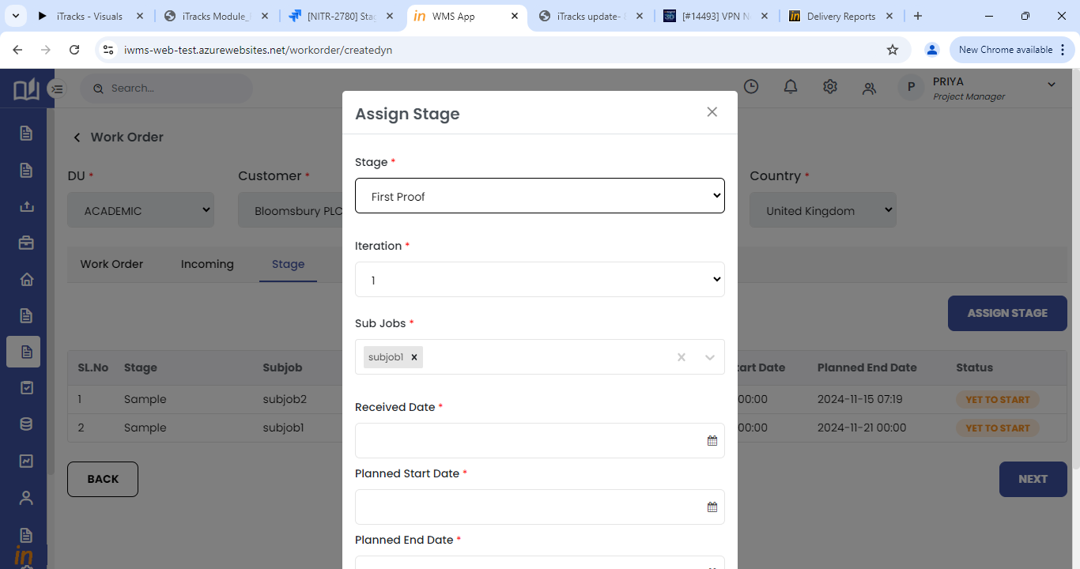

1. Once stage details are added, it will be displayed in the stage tab.

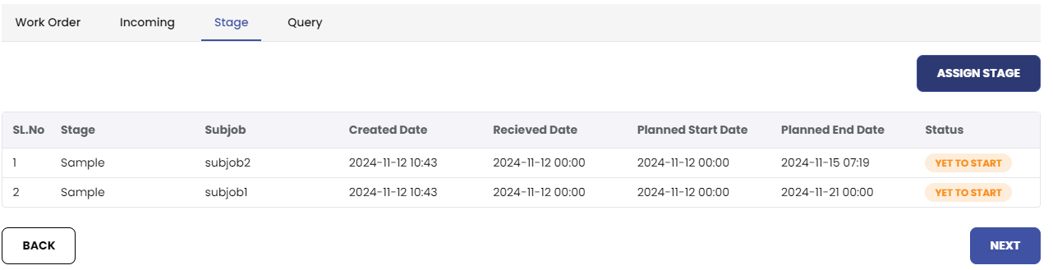

**Case 2:** PME team updated stage after incoming team has assigned stage to sub jobs

1. Click on Update due date tab to view and update due dates for the stages created.
2. PME will be able to select the created stages from the stage drop down.

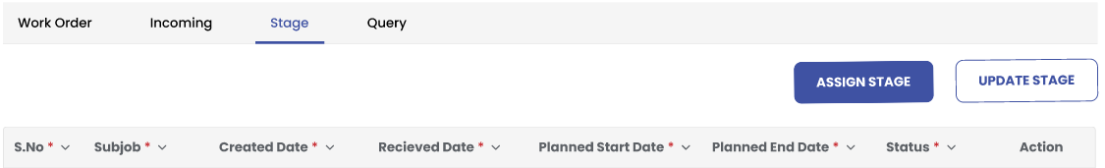

1. Once stage is selected, the assigned subjobs for the stage will only be listed.
2. PME team will be able to set due dates for the selected stage and sub jobs.
3. When a stage is created by the incoming team, cutoff time of two days will be given to PME team to update the due dates.
4. If the due date is not set within two dates, quality team will only have the access to update it later.

# Team Member user journey

## Accessing the Task- Manual Logistics Entry

1. Login with the right credentials provided.
2. Click on the Task menu in the side menu to view All Tasks and My Tasks tab. Use the scroll to move across the list

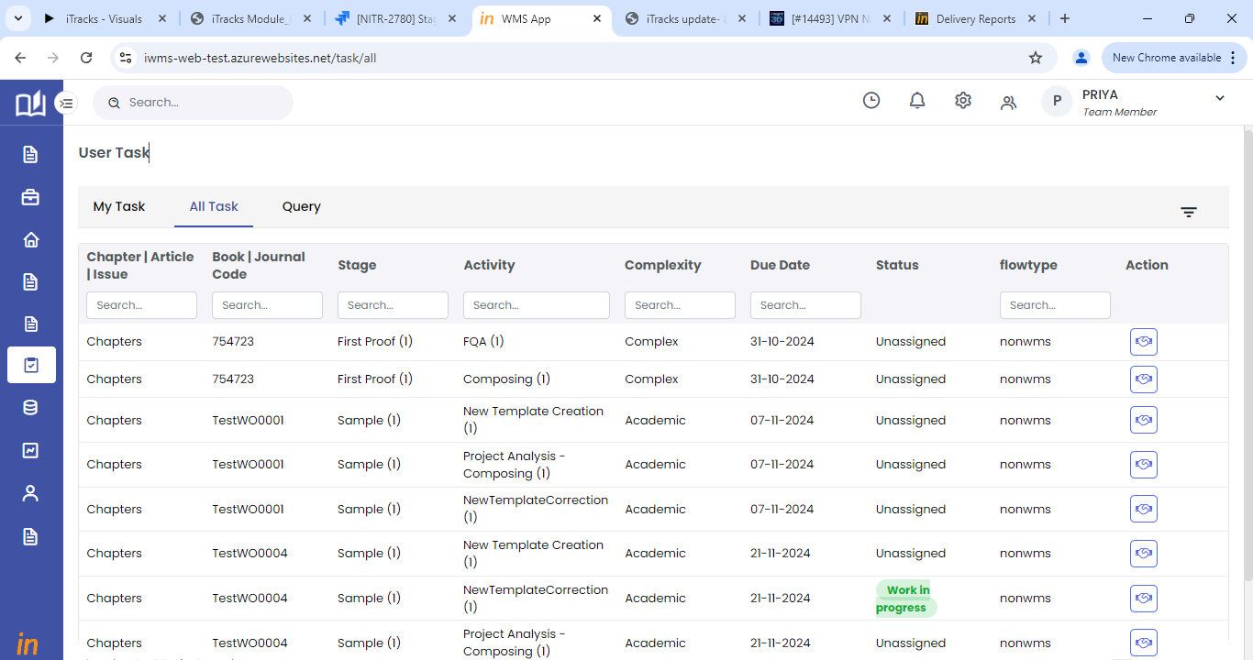

1. Click on the My tasks tab to view tasks claimed by yourself
2. Click on the View button to enter the task screen
3. In All Tasks tab, click on the Claim button to claim and view the task screen
4. Users will be able to search for the required task from the task list.
5. Once the task is claimed, it will be moved to the user’s queue to my task list.

## Task screen actions

1. Click on start to start the logistic entry for that task.
2. Once a task is started, it will be in the user my task list.
3. When the user completes the work, he can view the task from the My task tab.
4. Enter the total quantity of units worked and click on save or pending.
5. Save will close the logistic entry and complete the task.
6. Pending will move the task to All task list.
7. Reject button will reject file as per the workflow.
8. Click on the View Checklist button to answer instructions and to complete the checklist before saving the task. This is applicable only for production dispatch and customer dispatch.
9. Click the Cancel button to undo any changes made to the task and to go back to All task screen.

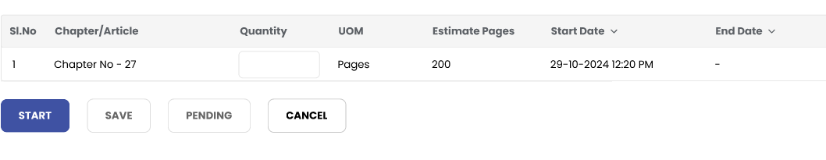

# Screens accessible by all users

## Query

1. Query tab can be accessed by all users from the below mentioned screens

* Work orders list screen under the expansion menu.
* Query tab in User Task List screen
* By clicking the Queries button on View Task Information screen.

1. The query tab in the work order screen will display all the queries raised for that work order.
2. The query tab in User Task screen will display all queries assigned to the skill of the logged in user.
3. Click on the view icon to view the query summary.

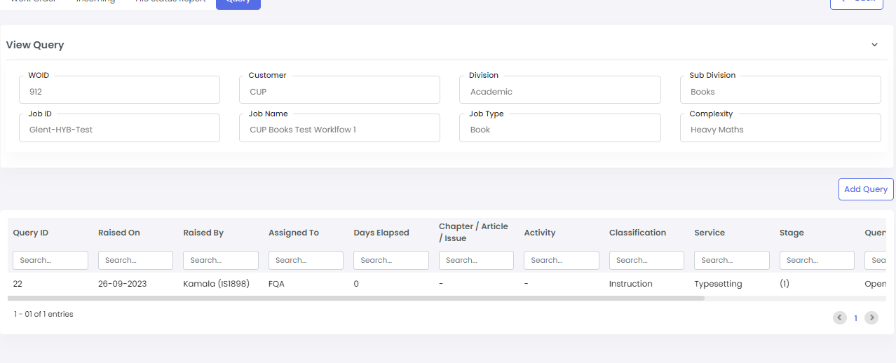

1. Click on the reply button to respond to the query.
2. Use the text box to respond to the query.
3. Click on the submit button to submit the query response.

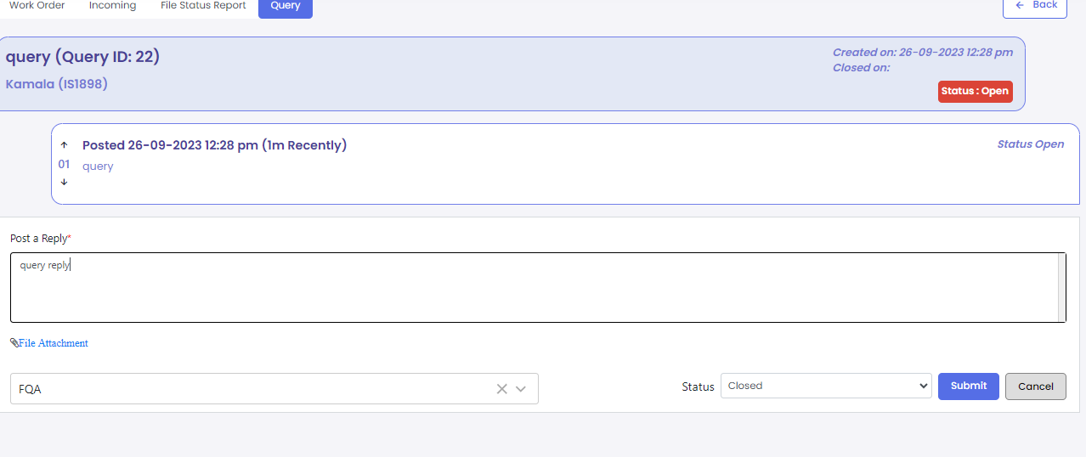

1. To create a new query, click on the Add Query button on query tab page
2. Choose required options and enter all mandatory fields.
3. Click on the save button to create the query or the cancel button to cancel the query creation.

# Reports

## On Time Delivery Report (OTD)

1. All users will be able to access the OTD report from the Reports menu in the landing page.
2. Login to the system with the right credentials provided.
3. In the landing page, click on the Reports menu to view the list of reports available.
4. Click on OTD Report to view the OTD report.
5. Select the DU and stage group from the provided drop down. (stage group filter is available only for single DU selection)

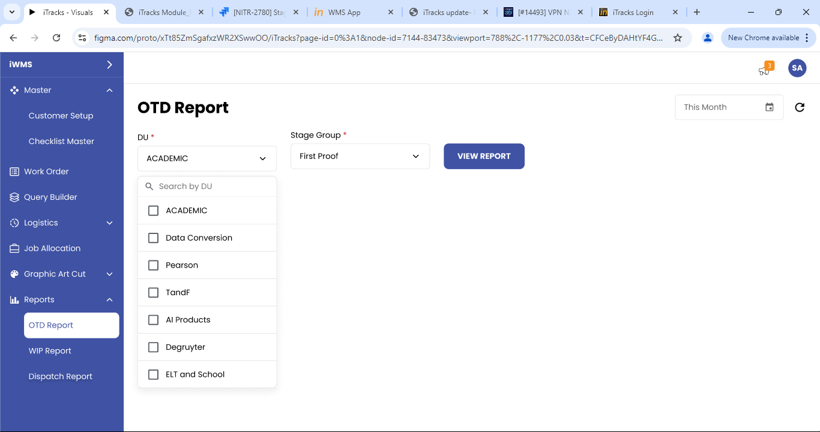

1. Users will be able to add stage groups and view existing groups from the stage group filter drop down.

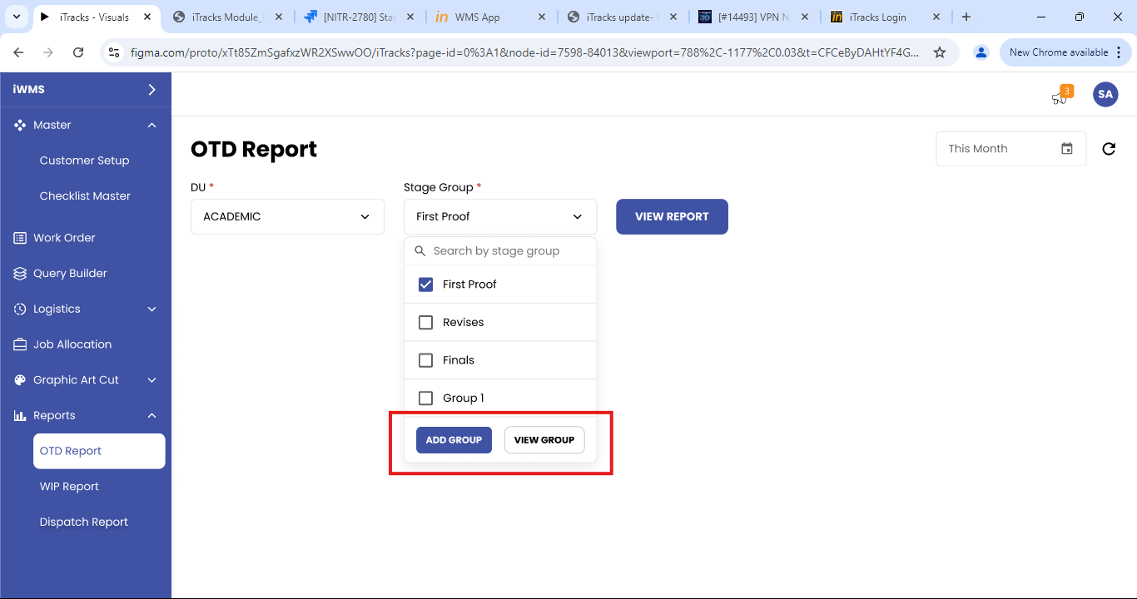

1. When DU and stage group are selected, the report will be shown stage group wise.
2. When multiple DUs are selected, the report will be shown DU wise.
3. Click on view report to load the report.
4. By default, the current month’s report will be loaded. Users will be able to change date range using the data filter.

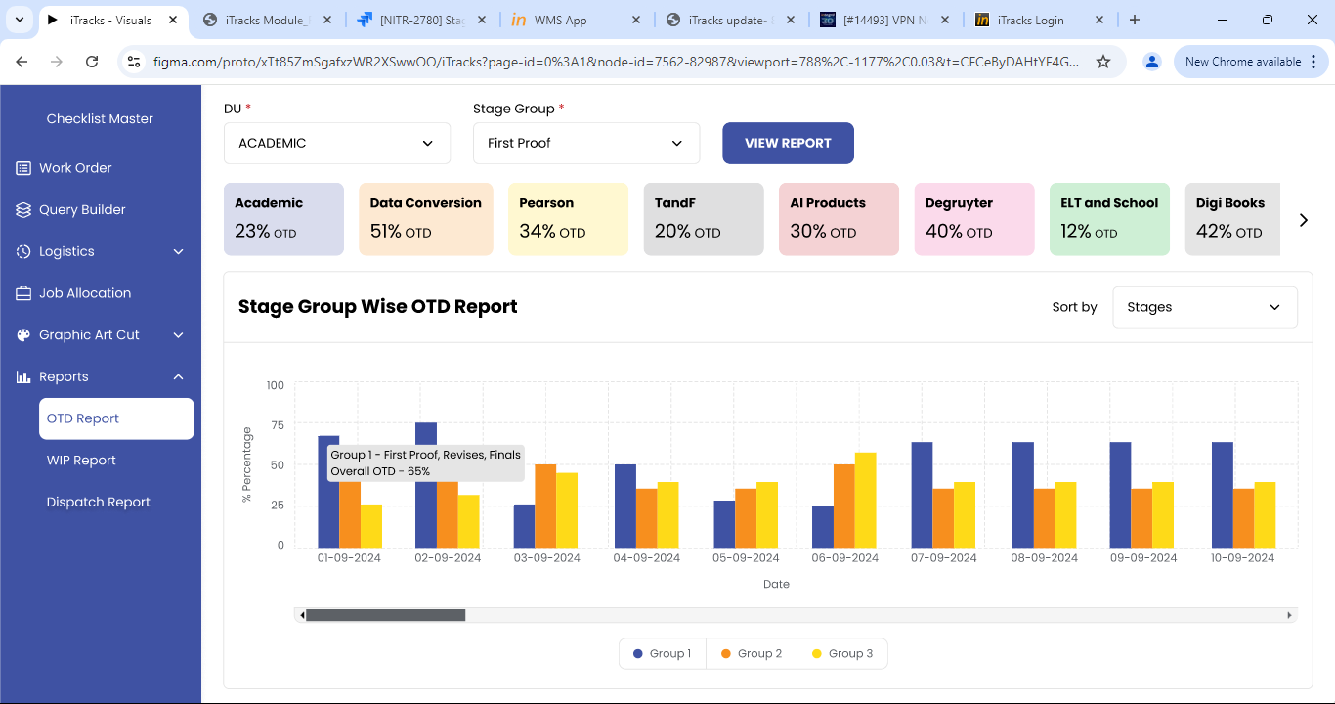

1. User will be able to view the report in both graph and table format.
2. Users will be able to view the current months OTD for all the DUs in small cards shown above the report. Use the scroll to move across the cards.

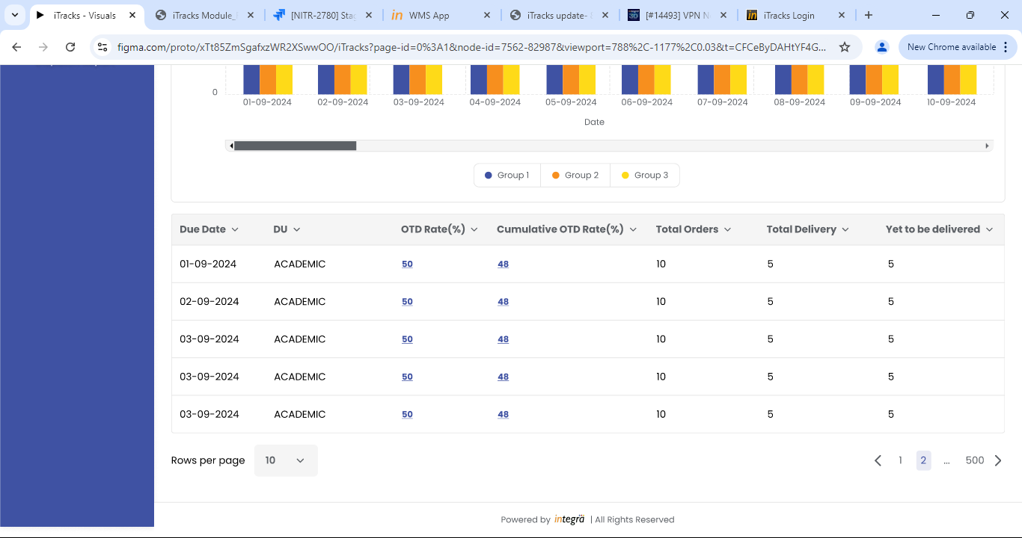

1. Click on overall or cumulative OTD percentage in the report table to view the customer level detailed data.
2. User will be able to select single or multiple customers from the filter.

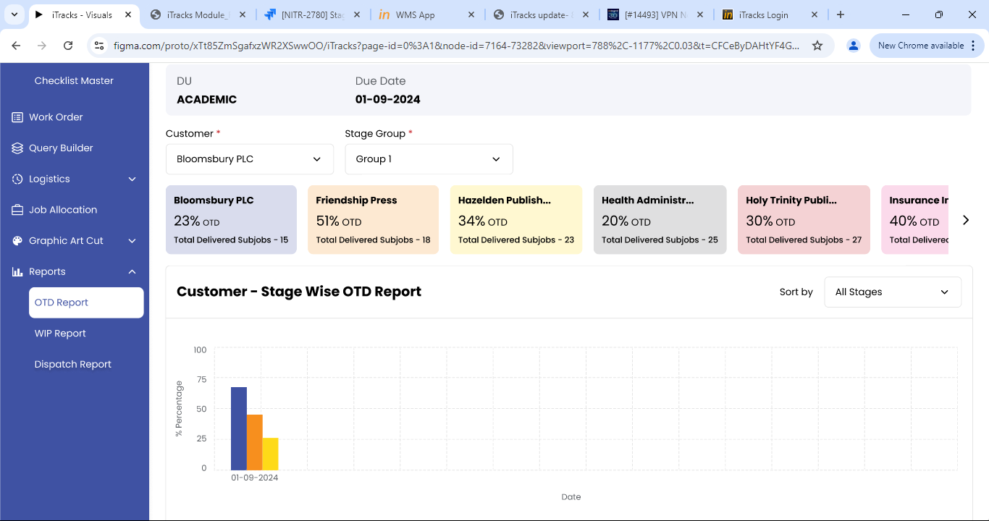

1. User the filters available to view the report as required.
2. Click on excel icon provided to export the report data.